Uva Wellassa University of Sri Lanka Faculty of Applied Sciences  Department of Computer Science and Informatics  Undergraduate Research Project (CST/IIT)- 2024/2025 |  |  |  | 
PROGRESS REPORT Report No: |  |  |  | 01
Name of the student/s: | W.K.Gayan
Registration Number/s: | UWU/IIT/21/062
Degree Programme/s: | Industrial Information Technology
Title of the Study: | AI-Based Tomato Ripening Stage Detection and Sorting System with Shelf-Life Estimation for the Commonly Consumed Padma Variety in Sri Lanka Using Computer Vision and Conveyor Automation
Institute/s where studies  are affiliated with: | Uva Wellassa University of Sri Lanka
Name of the Supervisor/s: | Ms. D.P. Jayathunga(Principle supervisor)  Dr. U.G.A.T. Premathilake (Co-Supervisor)  Ms. M.P.A.M. Rathnakumara (Co-Supervisor)
Period of Progress: | From:01/01/2026 |  | To:31/01/2026
Progress (A description by the Student).

1) Accomplished activities (Jan 2026 – current progress period)
The main work began in January 2026 with dataset preparation and early prototype planning. Padma tomato images were captured at the collecting center using a simple white-box lightbox with LED lighting to maintain consistent image quality. The captured images were then preliminarily sorted by ripeness stage and visible defects so they can be labeled later in Roboflow according to the five project classes.
In parallel, the fundamentals of the conveyor system were discussed and documented, including the approximate conveyor length/arrangement, planned positions for the camera and lighting above the belt, and the bin layout for sorting. Key hardware components (motor, actuator, sensors, and controller) were identified and their basic functions in the mechanism were defined. A draft cost estimate (prototype budget) was also prepared by approximating the prices of major components, intended to be attached to the monthly progress report.
In addition, initial model-development work was started by training a baseline CNN model for ripeness classification to establish an early performance reference. Based on the baseline results, the next step was identified as moving toward an object-detection approach (YOLO) to support real-time, full-frame grading required for conveyor-based sorting.
Milestones achieved
- Completed initial image capture setup and collected a first set of Padma tomato images using an LED lightbox.
- Completed preliminary dataset organization by ripeness stage and defect presence for future five-class labelling in Roboflow.
- Finalized an initial conveyor concept (layout, camera/light placement, and sorting-bin plan).
- Identified core hardware components and prepared an initial draft budget.
- Trained an initial CNN baseline model for ripeness-stage classification and documented observations to guide improvements.
- Defined the next modelling direction: test a YOLO-based model for full-frame, real-time ripeness/defect detection suitable for conveyor integration.
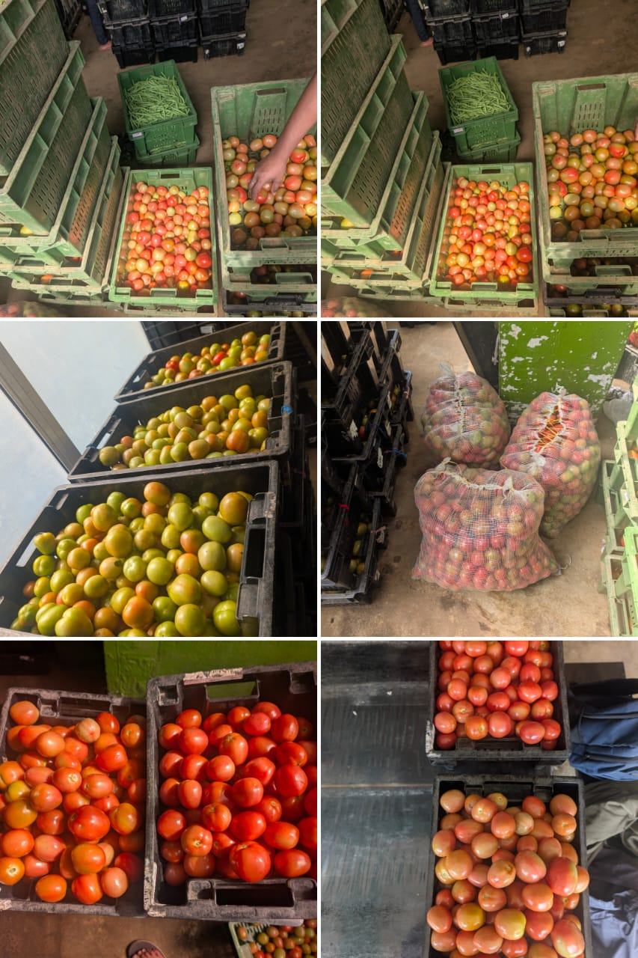
Figure 1: photographed in the collecting center

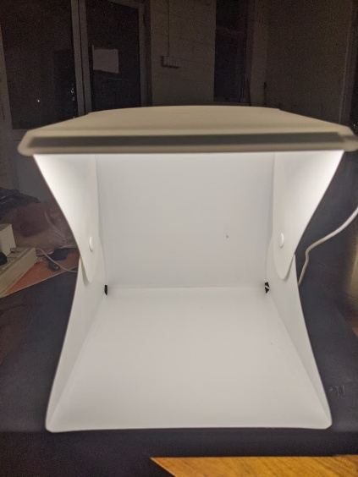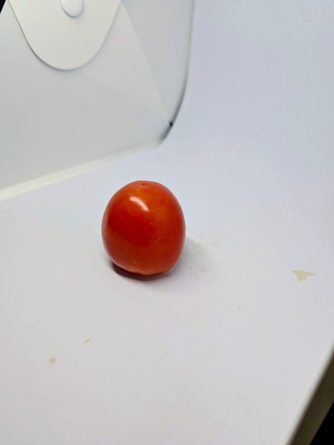
Figure 2: Lightbox used to capture images

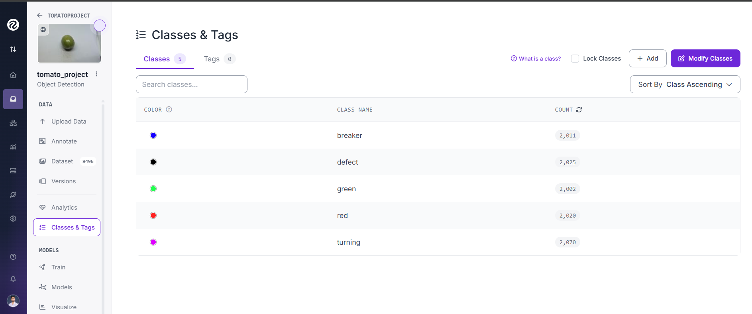
Figure 3: Class distributions of the dataset “Roboflow”

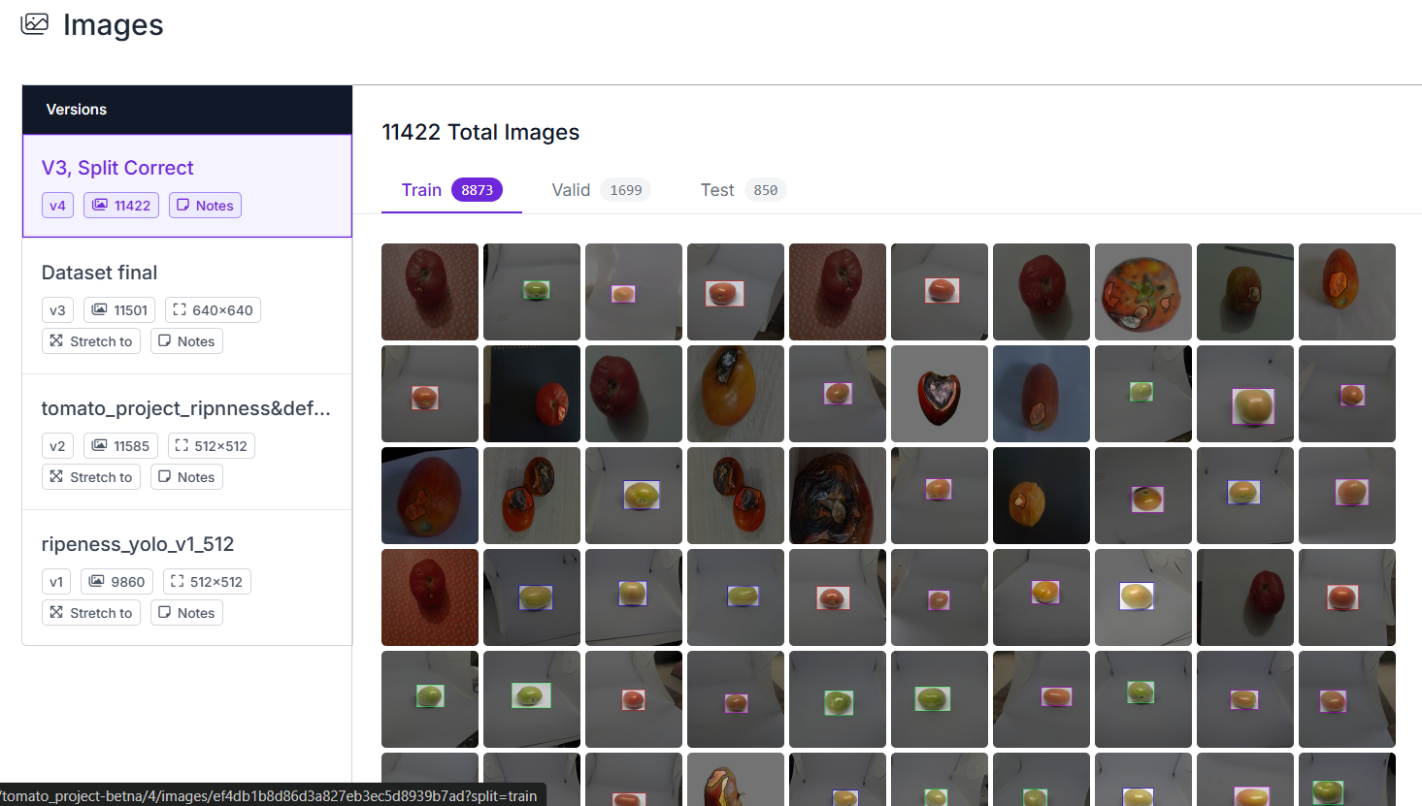
Figure 4: Dataset Preparations

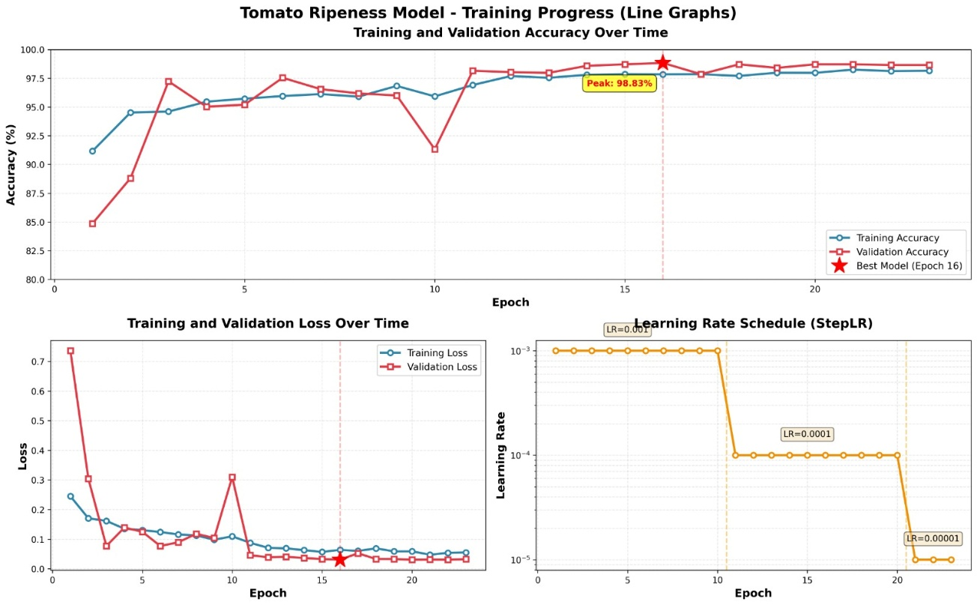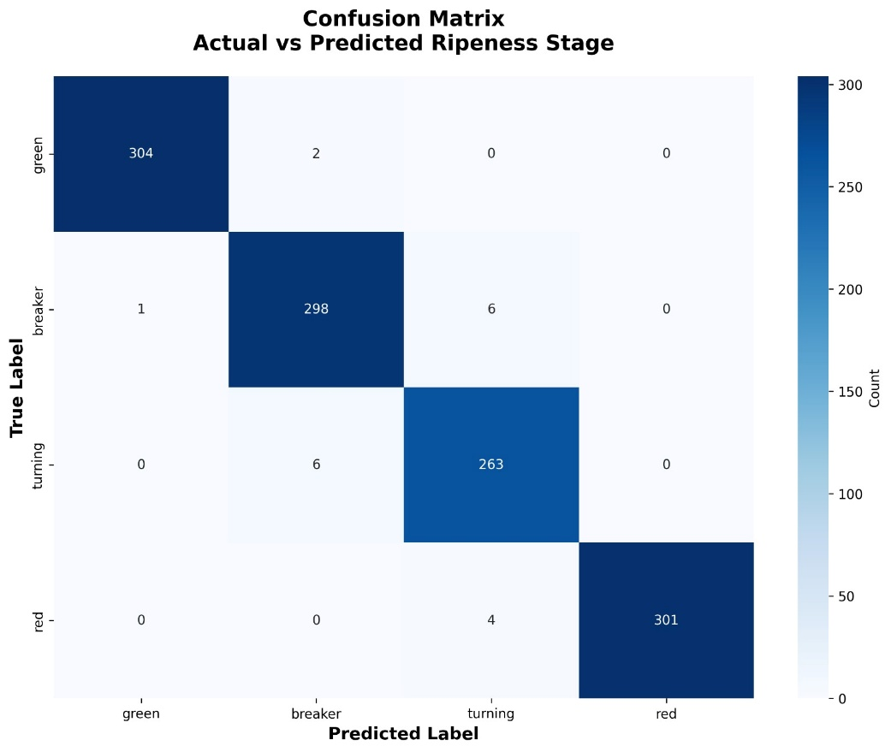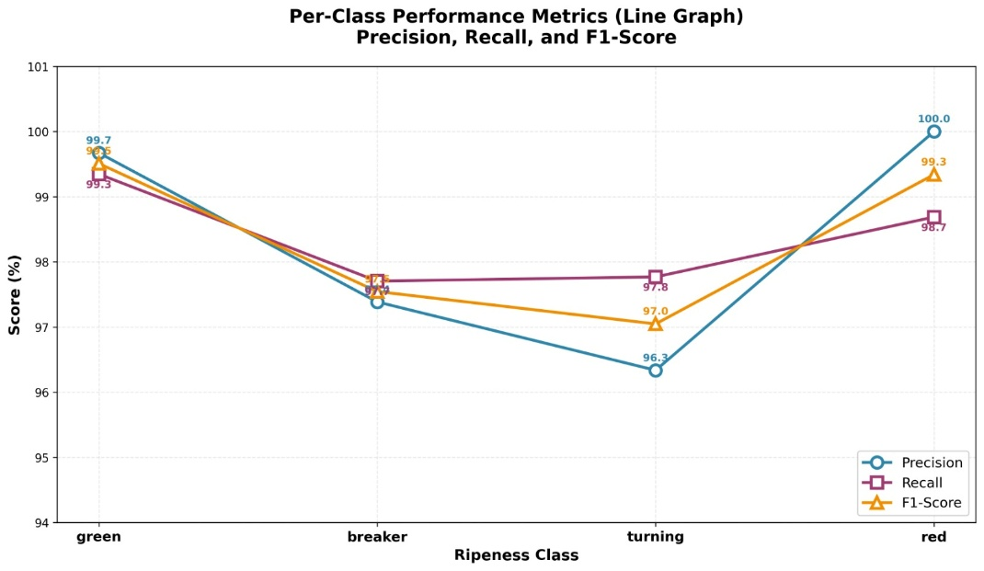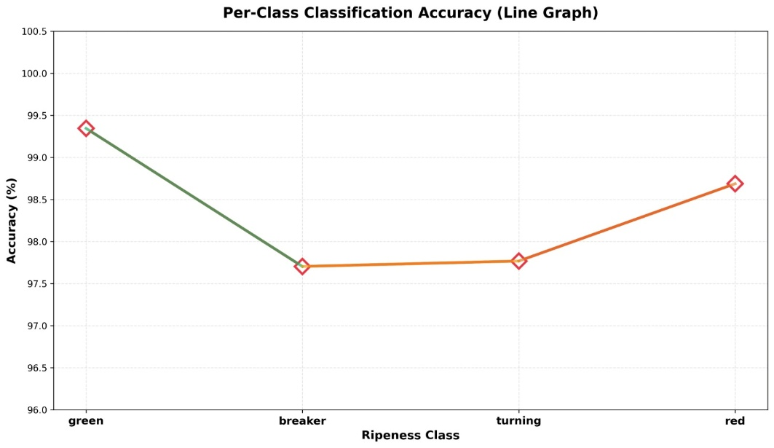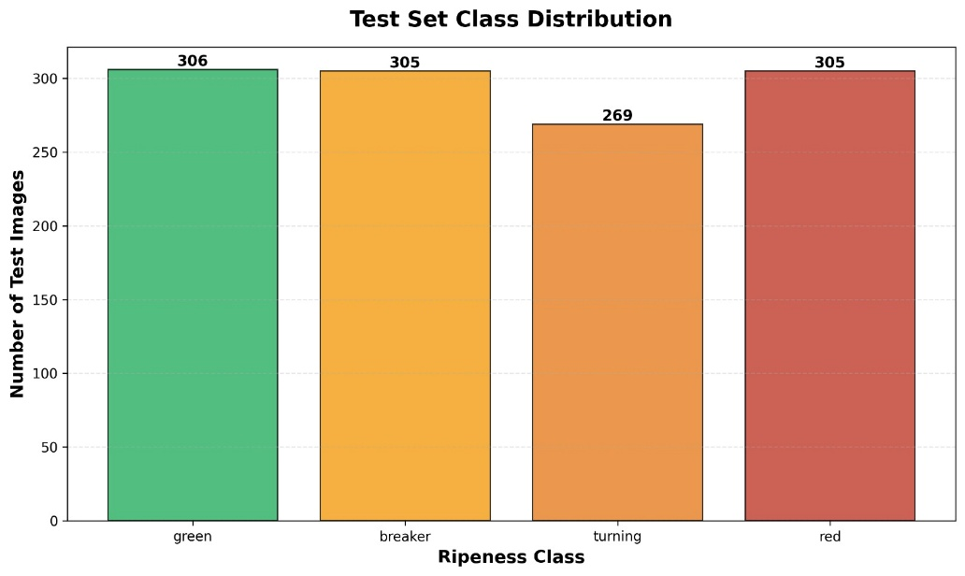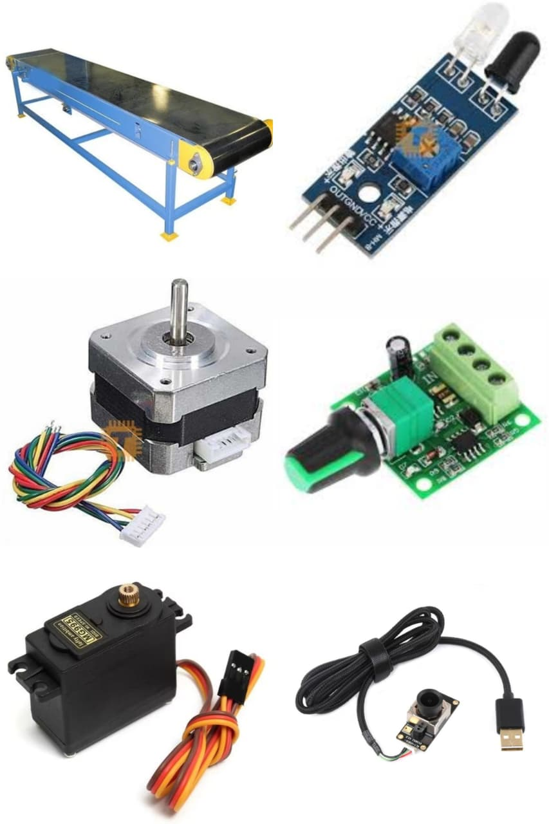

2) Activities planned before the next progress report (Feb 2026 – next period)
During the next progress period, the plan is to finalize the hardware prototype design by converting the earlier plan and draft budget into a detailed, build-ready 3D CAD model in SolidWorks. The CAD model will be developed to match the intended physical system as closely as possible, including the conveyor frame and belt path, motor mounts, camera stand, lighting holders, sensor mounting points, and actuator position. The design will be checked for correct dimensions and clearances, and refined where necessary before moving into fabrication and assembly.
Planned activities
- Confirm the final component set for the prototype based on the hardware list and draft budget.
- Complete the conveyor frame and belt-path design in SolidWorks with finalized dimensions.
- Add/refine mounting designs for the motor, camera, lighting system, sensors, and actuator to ensure stable installation.
- Validate clearances and alignment (camera-to-sorting distance, belt path, actuator reach) to avoid mechanical clashes and ensure feasible assembly.
- Update documentation so the CAD design, selected components, and budget remain consistent and ready for procurement/build.
- Defined the next modeling direction: test a YOLO-based model for full-frame, real-time ripeness/defect detection suitable for conveyor integration.

Signature of the Student: |  | 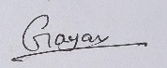
Approval Signature of Supervisor:
Approval Signature of Co-Supervisor (If any):
Date: |  | 12/02/2026

